

ACADEMIC YEAR 2025-26

DIBRIS
Robotics Engineering

Computer Vision
Second assignment:
NCC-based segmentation and Harris corner detection

Matteo Spluga Matricola: 9185902
- Introduction
The main objective of this laboratory activity was to implement the techniques of Normalized Cross Correlation (NCC) to identify a patch (a portion of an image) within the original image from which it was taken. In particular, NCC is used to avoid identification errors caused by variations in intensity and contrast, which, on the contrary, can produce undesirable effects when using simple Cross Correlation. Subsequently, the “Harris corner detection” technique was used to identify interest points in a given image in order to better detect key features that can provide a clearer understanding of what is shown in the image itself. All operations were carried out using MATLAB 2023b.

- NCC-based segmentation
Regarding the application of this technique, six very similar images were used, each with small variations in viewpoint. Specifically, the task required creating a patch of the red car, and then of the dark one, and subsequently searching for them respectively in all six images. The patch sizes are (350:450, 550:650) for the dark car (fig. 2c) and (330:460, 680:780) for the red car (fig. 2b). The reference image from which the patches were extracted (“ur_c_s_03a_01_L_0376”) (fig. 2a) and the patches themselves are the following:
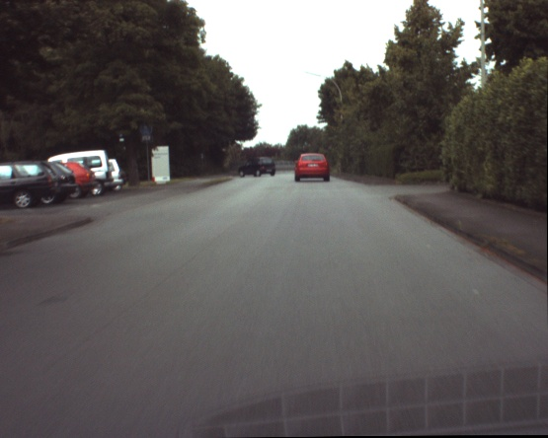
(2a)
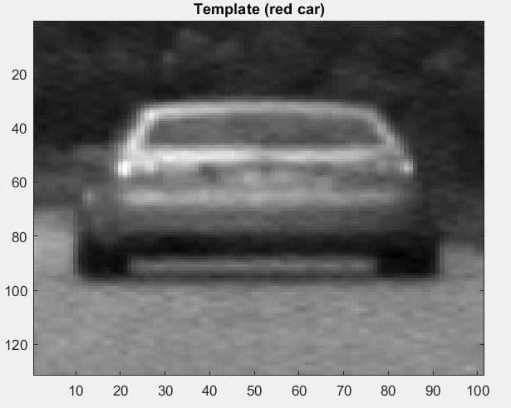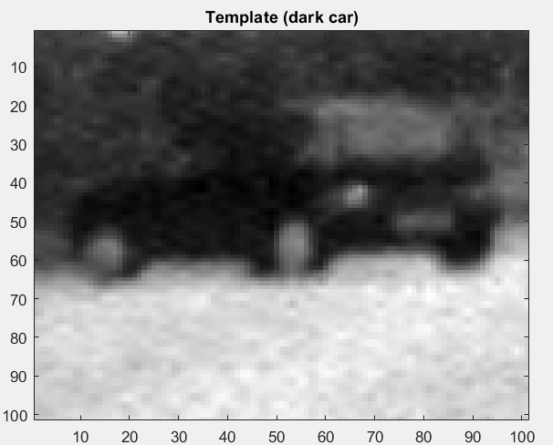
(2b) (2c)
Next, the Normalized Cross Correlation was applied using the normxcorr2 function in MATLAB. This function takes the template and “slides” it over the image, computing at each position how much it resembles the region of the image beneath it, thus creating a similarity map (Score map).
After this, all six images were printed with the addition of an identifying point at the maximum of the Score map (using the find function), surrounded by a rectangle of the size of the chosen template (by subtracting from the coordinates of the maximum point the size of the respective template along the x and y axes). Below (Fig. 2d and 2e) only two images are shown, corresponding to the identification of the maximum on the Score map associated respectively with the red and the dark car.
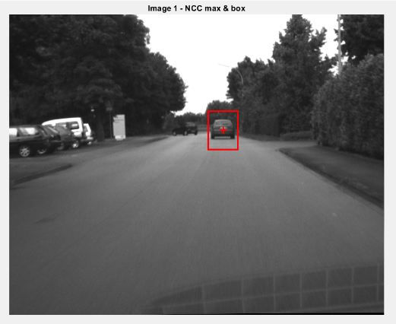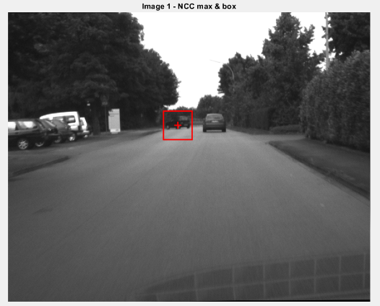
(2d) (2e)
It was then required to create three different patches around the dark car in order to make a comparison in terms of computation time and accuracy of detection. Below are the images from this study, considering patches created on the image “ur_c_s_03a_01_L_0376” (Fig. 2f, 2g, 2h, 2i, 2j, 2k). Only two additional patches of the three required were created, since the first patch (Fig. 2c) was chosen as one of the three. The patch sizes are (370:430, 570:630) for the small window and (330:470, 530:670) for the large window.
The patches are the following (fig. 2f e 2g):
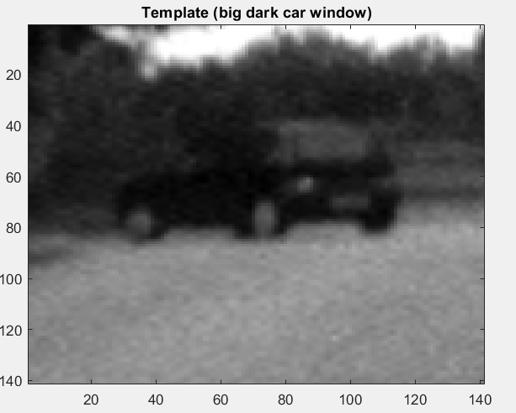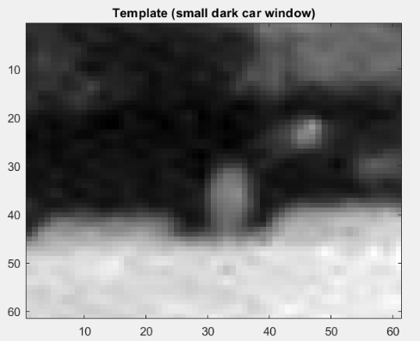
(2f) (2g)
The images with the maximum points of the Score maps are shown below (fig. 2h e 2i):
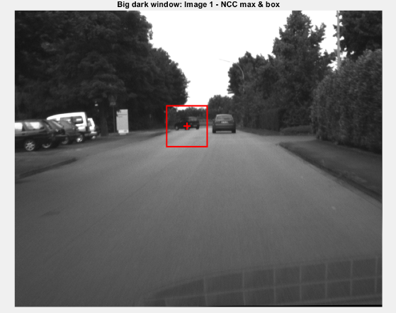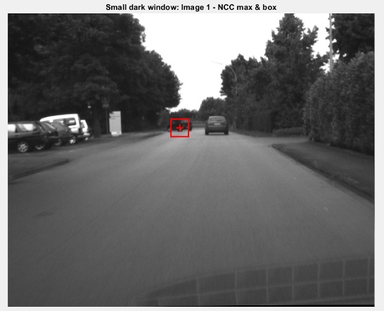
(2h) (2i)
From the Score maps obtained by applying the NCC-based segmentation technique, a difference can be observed in the clarity of the points of maximum intensity (which indicate where the patch is located in the image). In particular, from the Score map associated with the search for the smallest patch (Fig. 2j), it is evident that there is greater difficulty in finding the dark car (the patch is less clear in its details). In contrast, greater clarity (in terms of the position of the dark car) is visible in the Score map associated with the largest patch (Fig. 2k).

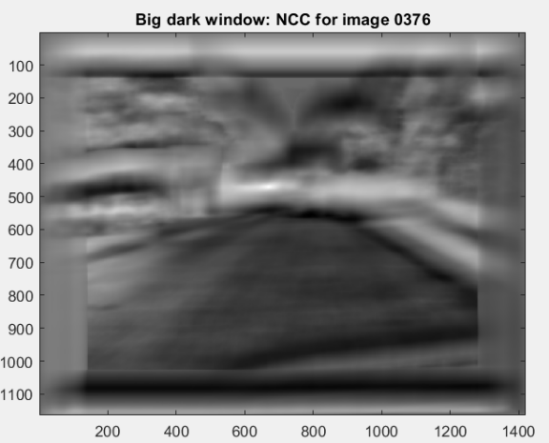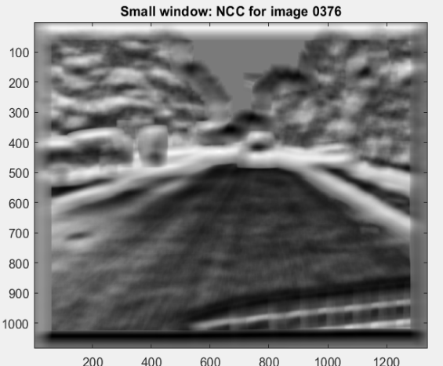
(2k) (2j)
From all three images with the framed maximum positions, no substantial differences can be observed in the location of the maximum. This may be due to the choice of patch sizes, which do not differ too much from one another.
However, intuitively, it can be noted that large patches containing more details may cause errors in locating the dark car if they are too large (also resulting in longer computation times). Smaller patches, on the other hand, allow for shorter computation times but may lead to additional difficulty in identifying the correct position if they are too small (thus removing necessary details for accurate identification).

Finally, some considerations are made based on the comparison between the NCC-based segmentation and the color-based segmentation studied during the previous laboratory activity.
NCC compares a template with regions of the image to find similarities: it is robust to changes in brightness but computationally expensive and sensitive to scale and rotation. Color-based segmentation, on the other hand, groups pixels based on their chromatic values (RGB/HSV): it is simpler and faster but more sensitive to illumination changes. In the project described, color segmentation exploits the Hue channel to identify the vehicles (first the red car, then the black one). After selecting the window containing the cars, the mean and standard deviation of the Hue are computed to create a binary mask that isolates the pixels within the range (μ − σ, μ + σ). This technique works well for the black car, because the Hue threshold clearly identifies the vehicle. For the red car, however, it fails: the threshold based on mean and standard deviation also includes unrelated colors, resulting in unwanted objects being detected. For this reason, it is preferable to use a fixed Hue threshold derived from the color wheel, which correctly isolates the red car.
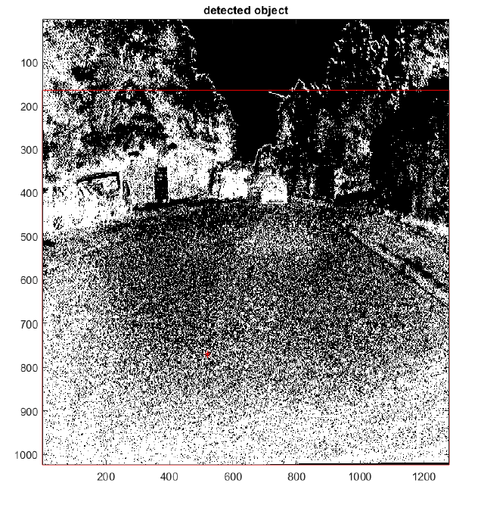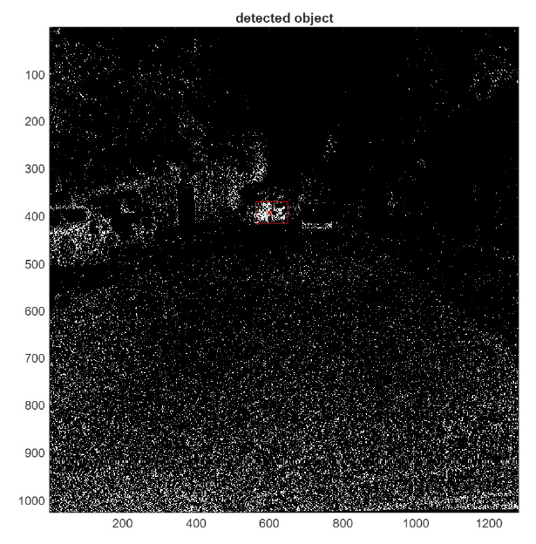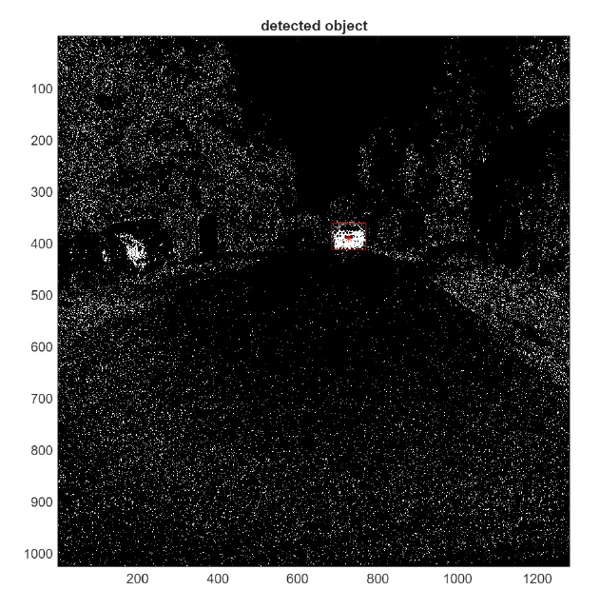
(2l) (2m) (2n)
From Fig. 2l, it can be observed that the color-based segmentation fails to identify the red car, while it successfully identifies the dark one (Fig. 2m). A correct identification of the red car can be achieved only when specific hue thresholds are used (Fig. 2n).

- Harris corner detection
Regarding the application of this method, a single image called “i235” was used. As already mentioned, the Harris corner detector is used to identify corners (angles, interest points) in an image. These points are areas with strong intensity variations in both directions and are extremely useful because they are stable, distinctive, and easy to locate again in other images. The algorithm was implemented by finding the derivatives along x and y of the image using Sobel masks to obtain estimates. This is done to understand how the image intensity varies along the two directions (to determine whether the point lies on an edge, on a corner, or on a flat region). The results of applying the derivatives to the image are shown in Fig. 3a and 3b.

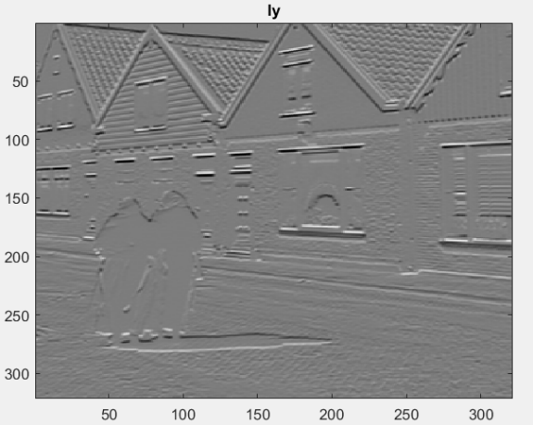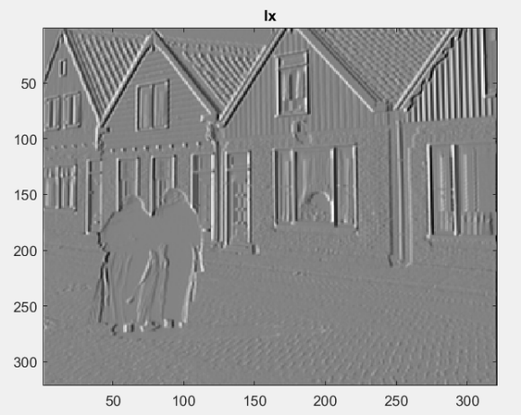
(3a) (3b)
In the code, the values of the gradients Ix2, Iy2, and Ixy were then computed, which form the entries of the matrix M, describing how the luminance changes around a point in the two directions. A Gaussian filter is subsequently applied to the gradients to reduce noise and to stabilize the matrix itself (Fig. 3c).
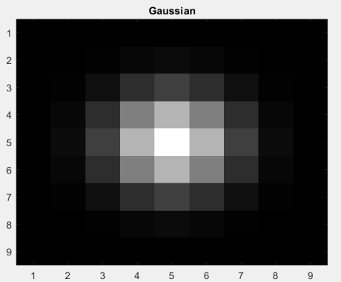
(3c)
It is very important to consider the computation of the R score map, which shows how strongly each point can be considered a corner (Fig. 3d). In fact, high values indicate the presence of a corner, moderate values indicate an edge, and low values indicate a flat region. Each pixel of the map was created using the formula $R=det(M)-α*({trace(M))}^{2}$, with α = 0,05.
Since corners are of particular importance, a corner map was also created to identify precisely this type of points (Fig. 3e), using a threshold of 0.3*M (with M being the maximum of the R score map, indicated in the code as Mmax).
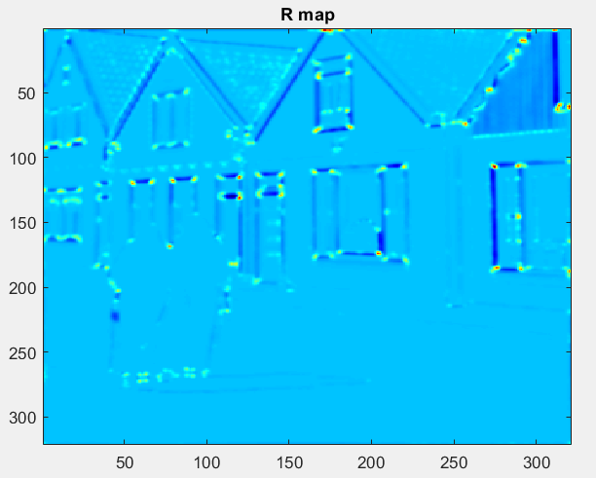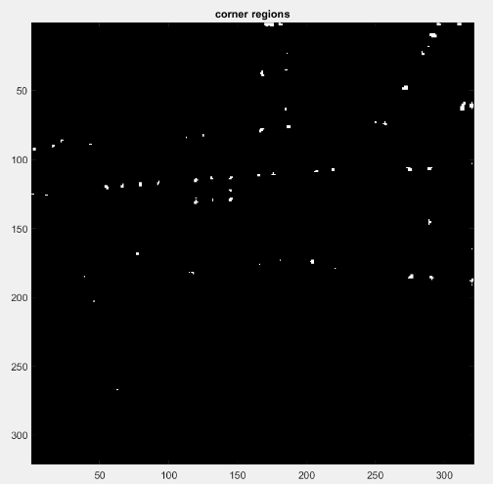
(3d) (3e)
Finally, the original image was modified by overlaying the corner points identified by the Harris corner detector, in order to show the accuracy of the algorithm (Fig. 3f).
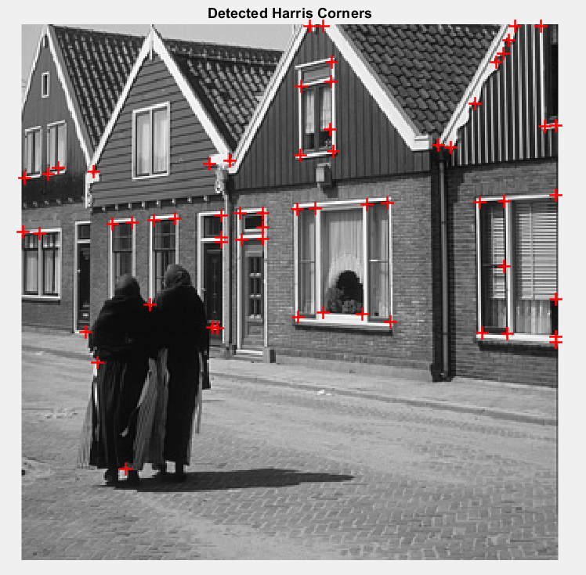
(3f)
It is clearly possible to observe a high level of precision in the identification of the corners.

